ServiceNow Twilio Flex Setup Instructions

1. Launch Studio by opening **System Applications > Studio** in the Application Navigator.



1. Studio opens in a new browser tab and displays the Load Application dialog.

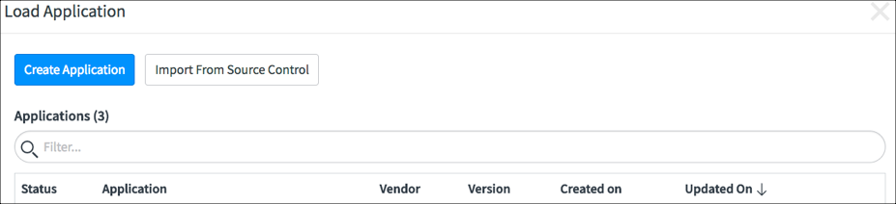

1. Click the **Import from Source Control** button then configure the connection to the source control repository.
   1. URL: <https://github.com/SWA-JB/ServiceNow-Twilio-Flex-Integration.git>
   2. Username and Password are not required

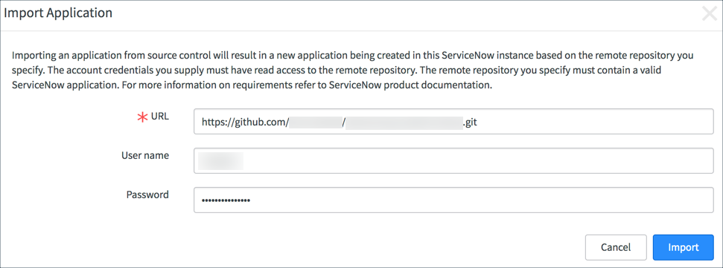

1. Click the **Import** button. A progress dialog appears. When the application import is completed, click the **Select Application** button.

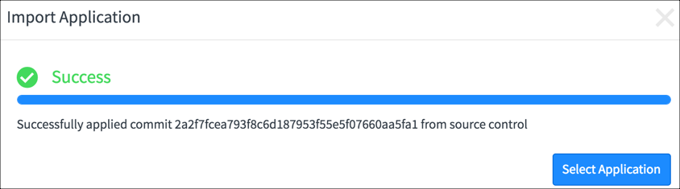

1. Create integration user by navigating to **User Administration > Users** and clicking **New**





1. ServiceNow opens the new user screen. Complete the form using the values as follows:
   1. User ID: twilio.flex
   2. First Name: Twilio
   3. Last Name: Flex
   4. Password: **a password of your choice**
   5. Web Service Access Only: checked
2. Click the **Submit** button to create the user record



1. Navigate to **System Properties > Twilio Flex**



1. Enter your Twilio Flex runtime environment name and click **Save**

